II. CHALLENGES AND RESEARCH QUESTIONS IN REMOTE SENSING
Solving long-standing challenges in 3D urban modelling has led to a switch from traditional photogrammetric workflows to neural rendering methods like NeRF and 3DGS. The literature reviewed in this survey addresses several questions that define the current state-of- the-art.
- Handling Multi-Temporal Radiometric Inconsistency
Remote sensing datasets, particularly those that involve multi-view satellite constellations or multiday UAV missions, are basically multi-temporal [7]. Particularly, images are obtained over vast time scales, leading to major changes in image appearance caused by changes in sun angle, atmospheric conditions, and phenology [7], [10]. As shown in Fig. X, these changes can take various forms such as seasonal appearance changes, shadow changes, and object changes. These radiometric changes cause major noise in the neural supervision signal, challenging the multi-view consistency assumption essential for stable optimization [7], [11]. Therefore typical models tend to suffer from convergence instabilities where the model is unable to detect surface reflectance from lighting conditions or atmospheric changes [7], [10]. The major challenge in this context is how these neural models maintain geometric integrity when the underlyting supervision signal shows global and local radiometric changes due to seasonal or atmospheric changes [7].

Figure:

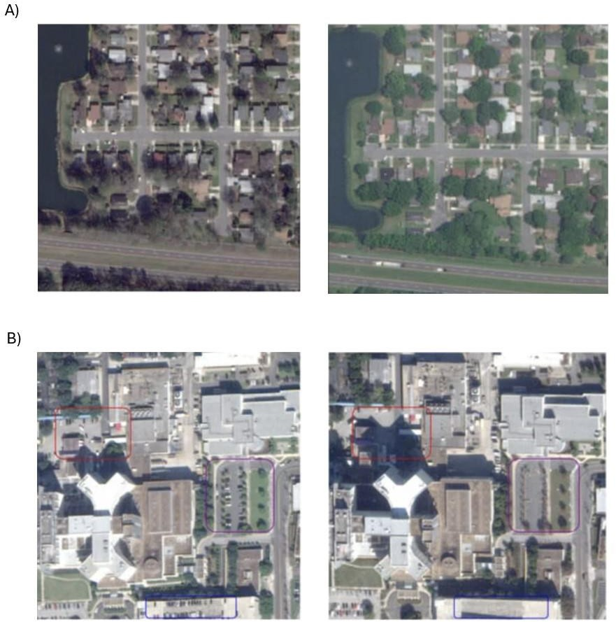

Fig. X. Multi-temporal radiometric inconsistency in remote sensing imagery: A) seasonal appearance variation and B) shadow geometry change and appearance of transient objects, such as vehicles, which impact photometric consistency and make neural rendering optimization difficult. [7].

To address geometric and radiometric consistency, neural frameworks make a distinction between static scene geometry from temporary appearance and lighting dynamics.
Appearance-adaptive latent is employed to describe the style of acquisition, with SatGS using a hierarchical model in which global embeddings at the pre-image level describe broad atmospheric changes, while local embeddings at the pre-Gaussian level accommodate spectral fine-tuning [7].
To improve modelling of acquisition-specific sensor responses, for example, EOGS++ uses learnable affine transformations for each camera, which map the invariant 3D features to colour channels at a specified timestamp [10]. Instead of treating shadows as noise, S-NeRF

and SatGS treat shadows as important information for geometry [7], [15]. This utilizes solar visibility fields and surrounding light from the sky to ensure consistency of shadows and buildings [7], [15]. Furthermore, in order to improve the robustness of the approach against temporary objects like moving vehicles, UPNeRF utilizes the uncertainty and visibility fields. This results in variance maps that reduce the loss for unreliable pixels, which prevents degradation of permanent scene structures [4].

- Solving Top-Down Bias in Vertical Reconstruction
Remote sensing data is primarily captured from top-down. This results in “TDB”, where vertical structures like building front-view suffer from significant information loss and structural ambiguity. This large difference in perspective makes the establishment of geometric correspondences between aerial rooftops and facades on the ground level an inherently ill-posed problem [12]. Without the availability of sufficient oblique imagery to provide side-view context, neural models often have difficulty disentangling the conflated
foreground buildings from the background terrain, leading to “jagged” or “sawtooth” effects that refers to geometric misshaping and serrated irregularities that appear along the edges, boundaries, and bases of reconstructed vertical structures, such as building facades or a complete absence of the vertical elements. As shown in Fig X, the key challenge that how neural rendering frameworks can solve the TBD inherent in vertical remote sensing imagery to accurately reconstruct vertical building surfaces and eliminate geometric features like jagged edges or the merged surface with ground.

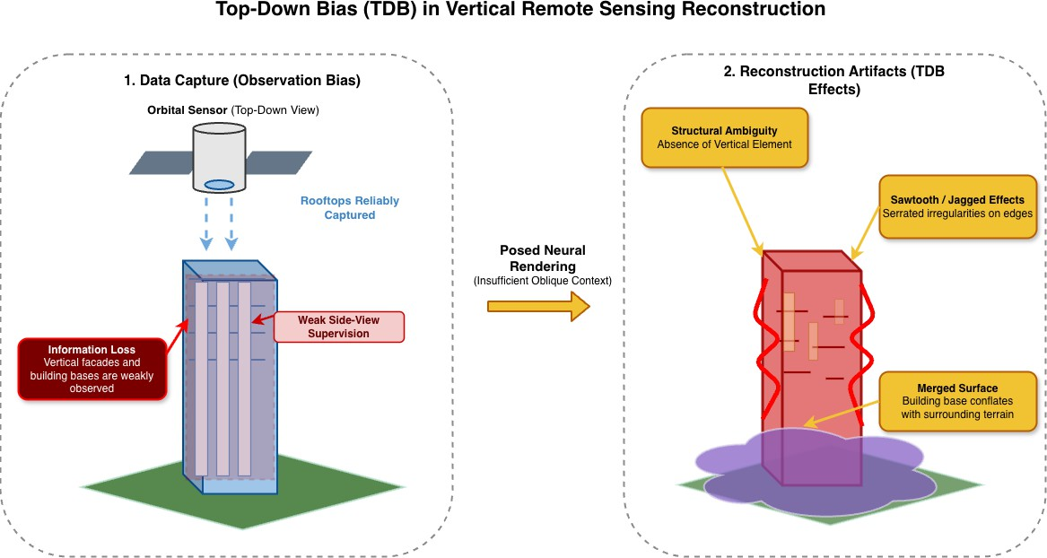

FIg. X The effect of Top-Down Bias (TDB) on vertical reconstruction. Cleanly top-down data capture (Left) results in extreme information loss on building facades. This lack of side- view context causes major 3D reconstruction artifacts (Right), including structural ambiguity, “jagged” or "sawtooth" edges, and the merging of the building base with the surrounding terrain.

Recent literature shows that this problem is increasingly addressed by neural frameworks leverage explicit geometric control of 3DGS and specialized loss functions to recover high- fidelity vertical structures. To address the “TDB” limitation in vertical reconstruction, these modern frameworks combine oblique and multi-perspective imagery for providing the necessary sideview context that is missing in predominantly nadir datasets [2], [5]. For
example, pipelines like Gaussian Building Mesh (GBM) and Ortho-3DGS utilize the benefits of multiple angular views to recover high-fidelity vertical geometry that is hidden or deformed in standard satellite-based reconstruction [8], [13]. This is further improved in cross-view tasks through the use of pseudo-aerial views at a significant pitch angle, like 45° or 60°, that allow the model to penetrate foliage and capture building sides shared by both ground and aerial views [12]. To complement this data integration, PG-SAG uses semantic- aware scene partitioning to address structural uncertainty between foreground buildings and surrounding background [11]. By using subgroups for scene partitioning, the model ensures that vertical facades do not overlap with the terrain [11]. PG-SAG introduces a boundary- aware normal loss to eliminate “jagged” or “sawtooth” effects commonly seen in traditional methods. This loss term reformulates the optimization process along the detected edges in a way that reduces normal vector ambiguity, which ensures better structural preservation [11]. Lastly, GBM-like frameworks provide better vertical fidelity by using morphological operations and/or contour simplification on building masks. This makes sure that the building bases are well-defined, which reduces any errors resulting from having no building masks fully cover the ground and the vertical facades of the building.

- Massive Data Size
There are significant hardware challenges in the transition from object-centric representations to city-scale digital twin representations due to synchronous optimization of millions of Gaussian primitives over entire urban districts, which overreaches traditional hardware’s VRAM limit, and this results in prohibitive computational latency [11]. For example, urban scenes at large scales require a large number of Gaussian functions to capture complex details, which can overwhelm GPU memory during both training and real-time rendering [8], [11]. As shown in Figure X, the major challenge in this is how explicit neural representations be scaled to city-scale digital twins without going beyond hardware limitations for VRM or compromising the high rendering speeds required for interactive applications.

Figure:

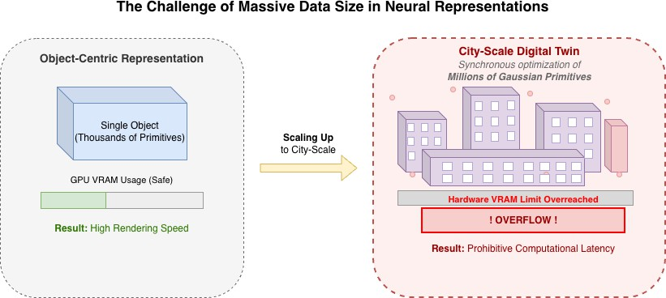
Figure X. An example of the scalability problem in explicit neural representations: Object- centric scenes can be reconstructed with high rendering speed and manageable GPU memory usage, but scaling city-scale digital twins requires synchronous optimization of millions of Gaussian primitives, which can introduce prohibitive computational latency and exceed hardware VRAM limits.

To address these challenges due to massive data scale, the current literature explores divide- and-conquer architectural approach based on spatial and semantic partitioning [Ortho-NeRF generating a true digital ], [PG-SAG Parallel Gaussian Splatting for
Fine ]. One of the major direction is spatial tiling, which is explored in Ortho-NeRF
framework, where large urban scenes are divided into geographically aligned tiles that can be reconstructed independently and later stitched into a coherent True Digital Orthophoto Map (TDOM) [Ortho-NeRF generating a true digital orthoph. ] [Comparative Assessment of
Neural Radiance ]. This reduces the memory load of monolithic optimization and
helps to avoid GPU memory overflow [Ortho-NeRF generating a true digital orthoph................], [PG-SAG Parallel Gaussian Splatting for Fine ]. Recent methods
like PG-SAG extend this idea through semantic-aware grouping, where building regions are organized accordingly to visibility relationships across registered images to allow more parallel and memory-efficient Gaussian optimization [HyGS-TDOM_A_Hybrid_Gaussian Splatting.................], [PG-SAG Parallel Gaussian Splatting for Fine ]. This is
mainly useful for preserving fine architectural details without depending heavily on image downsampling [PG-SAG Parallel Gaussian Splatting for Fine ]. Simultaneously, other
works explore parameter-efficient representations, that includes adaptive resolution control and multiresolution hash encoding (as used in Instant-NGP), to reduce memory consumption while maintaining rendering quality [Comparative Assessment of Neural Radiance..................], [Enhanced_3-D_Urban_Scene_Reconstruction. ], [Ortho-
3DGS_True_Digital_Orthophoto_Gener. ], [Ortho-NeRF generating a true digital
orthopho. ], []. These methods aim to assign model capacity more selectively, rather
than distribute uniformly across the entire scene [Ortho-NeRF generating a true digital

orthopho. ]. Finally, the literature explores progressive chunking as a solution for
seamless integration. These strategies investigate how aligning chunk boundaries through camera overlap can reduce the inconsistencies and artifacts that typically occur during the final merging of large-scale scene segments [Ortho- 3DGS_True_Digital_Orthophoto. ].

- Mixing Cameras: Multi-Sensor and Cross-Model Fusion
Integrating data from multiple satellite plat- forms is technically demanding because of significant variations in spatial resolutions and sensor characteristics over different missions [10]. When integrating datasets, it requires complex alignment and radiometric normalization, which can introduce noise and reduce structural accuracy. These limitations become especially important when spectral content from several sensors needs to be combined with high-resolution geometric data. As shown in Fig.X, the main challenge here is how can high-resolution structural information be effectively merged with spectral data from diverse sensors without incurring artifacts and inconsistencies related to traditional preprocessing steps, such as pansharpening [10].

Figure

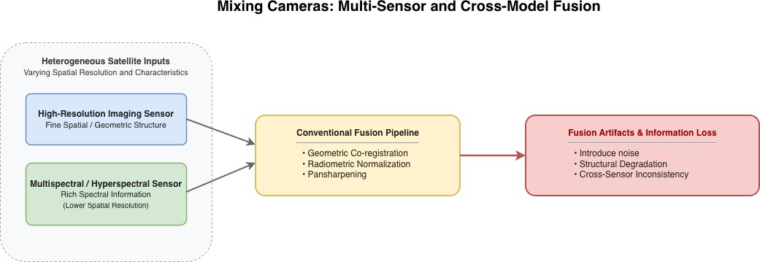
Figure X. the difficulties in cross-model and multi-sensor satellite fusion. Before fusion, co- registration, radiometric normalization, and pansharpening are required for lower-resolution spectral data from heterogeneous sensors and high-resolution structural imagery. These preprocessing procedures usually result in cross-sensor inconsistencies, noise, and structural degradation.

As indicated by literature, particularly EOGS++ framework that proposes a shift toward
pipelines with “virtually zero” required preprocessing by operating directly on raw data [10].
To avoid spectral artifacts and spatial blurring that is com- mon in external pansharpening, EOGS++ introduces a “Direct Rendering” approach. This approach works directly with raw high-resolution panchromatic (PAN) images, without the need for low-resolution

multispectral data for geometry estimation, to maintain the maximum amount of structural details. This is done by creating a three-channel representation by duplicating single-channel PAN data, and the model directly optimizes a stable 3D core against high-resolution observations [10].
Any misalignment caused due to the use of different camera types and timestamps is corrected using internal bundle adjustment (BA) embedded directly into the training loop. The framework calculates displacement fields to align rendered views with reference images using readily available optical flow estimators like RAFT. This eliminates the need for external optimization software and corrects pre-camera pixel offsets and pose errors. This integrated approach ensures that structural data from different sensors is geometrically consis- tent and produces much sharper results than the initializations using raw RPC data [10].

